
Name: ______________________ Class: ______ Time: 30 minutes Total Mark:____/39
Year 7

Mini Test 5

Show working and answers on this sheet. Show working in sufficient detail to support your answers. Incorrect answers without supporting reasoning may be allocated zero marks.

No Resources Allowed

- Write in index form.
[3 mark]
  - $8×8×8$

  - $4×4×4×4×4×4$

  - $2×5×2×5×5×5$

- Write in expanded form.
[2 mark]

  - ${10}^{2}$

  - $6^{4}$

- Find all the factors of each of the following numbers
[5 marks]
  - 21

  - 28

- Complete the factor tree below and use this to write down the prime factors of 210
[4 marks]
210

$210=_____________________________$

- By drawing a factor tree or otherwise, use index notation to express 60 as a product of its prime factors.
[5 marks]

- Use your answers to questions 4 and 5 to find the:
[4 marks]
  - Lowest common multiple of 60 and 210.

  - Highest common factor of 60 and 210.

- Use the diagram below to find $4^{2}$.
[1 mark]
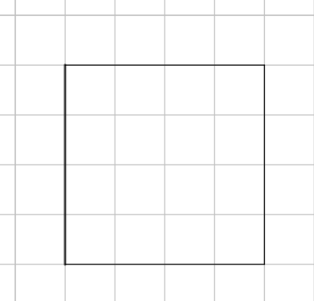

$4^{2}=$

- On the grid below draw a square with an area of $9{cm}^{2}$.
[2 marks]
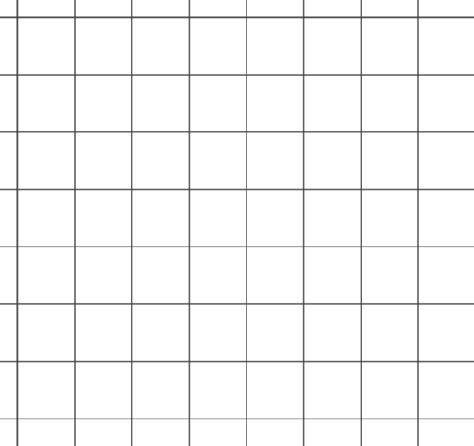

What is the side length of the square?

- A square as an area of${ 100cm}^{2}$. Find the length of one of the sides.
[1 mark]

- Calculate the value of the following
[5 marks]
  - $5^{2}=$

  - $\sqrt{25}=$

  - $\sqrt{900}=$

  - $\sqrt{0.36}=$

[2 marks]
  - ${4.7}^{2}$ is between which two square numbers?

  - $\sqrt{20}$ is between which two whole numbers?

- Evaluate the following
[5 marks]
  - $5+\sqrt{49}=$

  - $\sqrt{16}-2×12=$

  - $\sqrt{4^{2}+3^{2}}=$

END OF TEST

